Project Design Phase-II
Technology Stack (Architecture & Stack)

Date | 18th June 2026
Project Name | ShopEZ
Student Name | Akshara Cheedalla

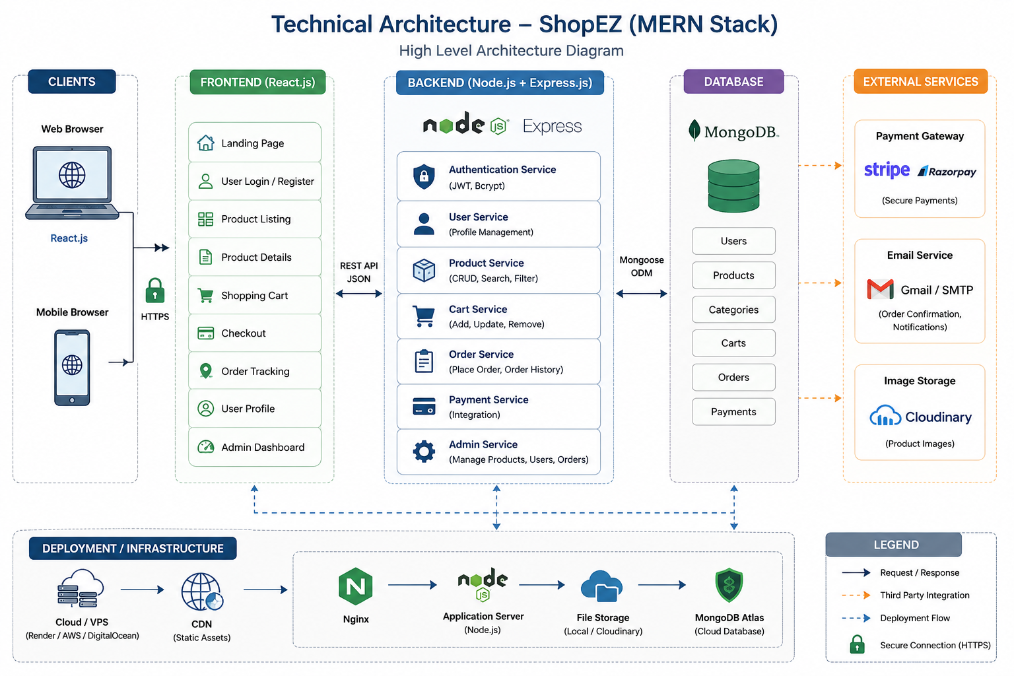

Table-1 : Components & Technologies:

S.No | Component | Description | Technology
1 | User Interface | Web application for customers and administrators | HTML5, CSS3, JavaScript, React.js, Bootstrap
2 | Application Logic-1 | User Authentication & Authorization | Node.js, Express.js, JWT, bcrypt
3 | Application Logic-2 | Product, Cart and Order Management | Express.js REST APIs, Node.js
4 | Application Logic-3 | Admin Dashboard, Analytics & Product Management | React.js, Express.js
5 | Database | Stores users, products, categories, carts and orders | MongoDB, Mongoose ODM
6 | Cloud Database | Database hosting (Future Deployment) | MongoDB Atlas
7 | File Storage | Product images and static assets | Local Storage / Cloudinary (Optional)
8 | External API-1 | Payment Processing | Stripe API / Razorpay API (Future Integration)
9 | External API-2 | Email Notifications | Nodemailer / Gmail SMTP
10 | Machine Learning Model | Product Recommendation System (Future Enhancement) | Recommendation Engine (Optional)
11 | Infrastructure (Server / Cloud) | Application Deployment | Localhost, Render, Vercel, MongoDB Atlas

Table-2: Application Characteristics:

S.No | Characteristics | Description | Technology
1 | Open-Source Frameworks | Open-source frameworks used for frontend and backend development | React.js, Node.js, Express.js, Bootstrap
2 | Security Implementations | Secure authentication, password encryption, protected APIs | JWT Authentication, bcrypt, HTTPS, CORS
3 | Scalable Architecture | Three-tier MERN architecture with REST APIs supporting future expansion | MERN Stack, MVC Architecture
4 | Availability | High availability through cloud deployment and reliable database services | MongoDB Atlas, Render, Vercel
5 | Performance | Fast API responses, optimized database queries, efficient frontend rendering | React Virtual DOM, Express.js, MongoDB Indexing

